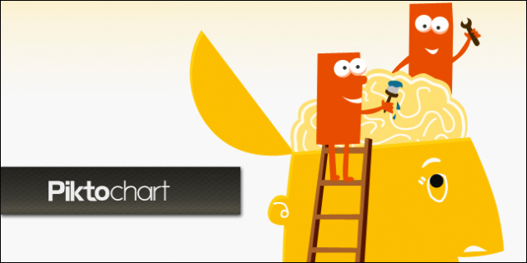
All About Me Infographic: Final Rubric
Student Highlighting
Teacher Highlighting

Name of Designer: ________________________
Piktochart Icon by Piktochart.com

Standards on Report Card | 4 | 3 |  | 2 | 1
Creativity and Innovation | The infographic has a powerful presence. It has an above average design look. | The overall look and design of project is pleasing to the eye, with no noticeable issues. |  | The infographic has only a few issues with colors, images, or text that make it a bit hard to read. | The infographic is hard to read/understand.
 | The images chosen for the infographic were created or modified in order to have a larger impact. | Infographic includes images that match the content well. |  | At times images don’t match content well OR infographic could use more images. | There is a disconnect of images and content OR little to no images were used.
Student explanation for 4: |  |  |  |  |  |  |  | Images found online are cited on the infographic.
Digital and Global Citizenship | Credit is given for images used, and is done so in a creative way that enhances the design. |  | Images found online are cited with file name and creator. | The URL is given for images used. | Citations are missing.
 | Credit is given to PiktoChart for icons used, and is done so in a creative way that enhances the design. |  | Credit is given to PiktoChart for icons used. | Watermark is the only evidence of credit given for use of Piktochart icons. | Credit is given to PiktoChart for icons used.
Student explanation for 4:
Communication and Collaboration | Infographic incorporates the use of a variety of pictures, diagrams, and charts with minimal words to share a message in a clear and concise way. |  | Minimal blocks of text are used to share ideas. Other graphics also help share more information. | The text tells the message, and the images show a representation of that same message. Images are not used to REPLACE words. | The message in the infographic is unclear.
 | The infographic has shared all required information with great detail, and more! |  | The infographic has shared all the required information with some detail. | The infographic has shared all the required with minimal to no detail. | The infographic is missing basic required information.
Student explanation for 4:
Technology Operations and Concepts | Navigated PiktoChart with great ease. Adding and modifiying several more than 3 elements on PiktoChart  And/or used other tech tools to enhance PiktoChart. |  | At least 3 elements of piktochart are used. (text, change color, size, insert a shape or icon image, create a graph or diagram, add addition boxes, change background, etc.) | Kept the same design substituting only words and images on PiktoChart Template. | Was not able to use PiktoChart independently during the project.
Student explanation for 4:
Research and Information Fluency | Was able to take the quizzes online and transfer the information to infographic as well as use that insight to create new thoughts and ideas. |  | Was able to take the quizzes online and transfer the information to infographic. | Took online personality quizzes, but was unable to transfer that information to infographic. | Did not complete self analysis portion of infographic, because research was not complete.
Student explanation for 4:
Critical Thinking and Problem Solving | Was able to troubleshoot when problems arose during project AND was able to help others and show several tips and tricks. |  | Was able to troubleshoot when problems arose during project, and after trying several times sought for teachers help. | Sought out teacher’s help immediately when problems arose. | Completed entire project with teacher.
Student explanation for 4:

Final Comments:

Student Comments to Teacher:  (What did you think about the project? Was it too hard, too easy? What do you want me to know about your work on it that you haven’t shared? Is there something you are interested that you would like me to know?) | Teacher comment to students:

